Tyrell Map Editor Guide

**Software By:** Marco Hampel **Version** 0.1

Welcome to Project Tyrell. This editor serves as a means to create/change/delete parts of the game’s world map. Like in other strategy games, Project Tyrell will operate using a polygon based province system where the map is separated into hundreds of provinces, each province represented by a irregular polygon. To load these maps, a format built in Json is created which the game understands and can load to create the world map.

These maps can become increasingly complicated as hundreds to thousands of provinces exist across game maps. Therefore, this editor serves to automate/aide in the creation of these json map files. This guide will explain how to use to the Software and provide tips on getting started with it.

# Quick Start Guide

Upon opening the software you will be guided to this screen.

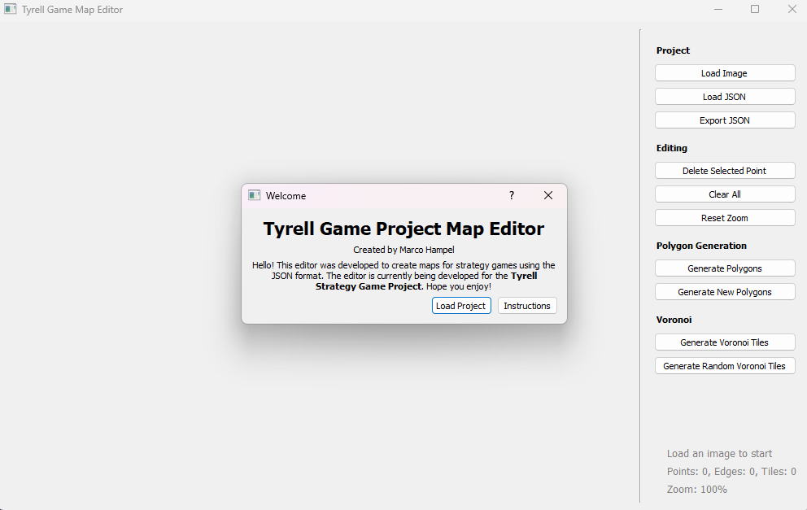

**Load Project**: Will have you first load a image file to represent the reference backdrop you want you want to build your map off of. Then it will require you to specify the json file you want to load. If you do not have an existing project/file, disregard.

**Instructions:** The instructions button gives an brief overview of the software’s functionality.

## Setting Up A Project

Click on **Load Image** under the *Project* tab to load an image file into the project this is your backdrop.

**Basic Controls**:

* *Zooming:* Zoom in/out with your scroll wheel.
* *Panning:* Hold middle mouse click and move your mouse to pan.

## Building Provinces

To start building provinces, we need to define vertices that will define our shapes. Zoom in somewhere you want to create a province and **Left Click** to create a point. You will see a red dot appear with a number on it.

Create more dots to form the shape of your province.

*Tip:* *Avoid adding too much detail. Some of the automatic systems take a long time to make calculations if geometry is too high.*

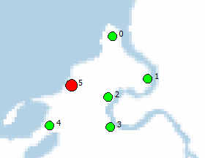

Here is an example of a basic province shape.

**Creating an Outline**

Now, double click on the point you want to start (it should highlight red) and hold left shift. Then click on the first point you want to connect.

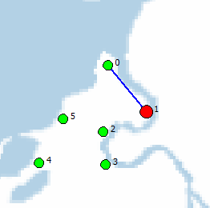

The selected point should move to the target and a blue line forms between them.

Continue from here until you have an enclosed polygon.

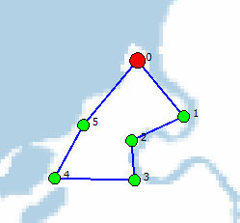

**Generating a Shape**

Now, once you have generated this shape, click on **Generate New Polygons** under the *Polygon Generation* tab.

*Note:* ***Generate New Polygons*** *and* ***Generate Polygons*** *are different.* ***Generate Polygons*** *will rerun the entire polygon generation script resetting ALL provinces. This is a costly function to run, so be ready to wait many minutes if you have too many vertices+edges.* ***Generate New Polygons*** *only runs on points that were created this session. So make sure to save frequently.*

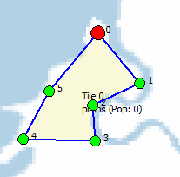

This is what a completed tile should look like.

**Moving Vertices**

If a point is not in the exact place you like, you can double click, then hold the left mouse button and move your mouse. The selected point will move with it. If a province/polygon was already generated, the polygon will shift with it.

**Deleting Vertices**

If you make a mistake or want to make a new tile/polygon. Right click on the target vertex you want to delete. If a polygon was already generated with it, the polygon/tile will be deleted as well. This is a good tool to use if you want to redesign borders in clustered areas, or just want to undo a mistake.

## Editing Provinces

If you want to update details about a province that will appear in game, click on a completed tile. A sequence of popups will appear asking for information about a tile. If you only want to change one thing, feel free to click OK and continue until the relevant information appears.

# Generating Maps with Voronoi

**What is Voronoi?**

Voronoi is an algorithm created to generate shard-like diagrams such as the one below:

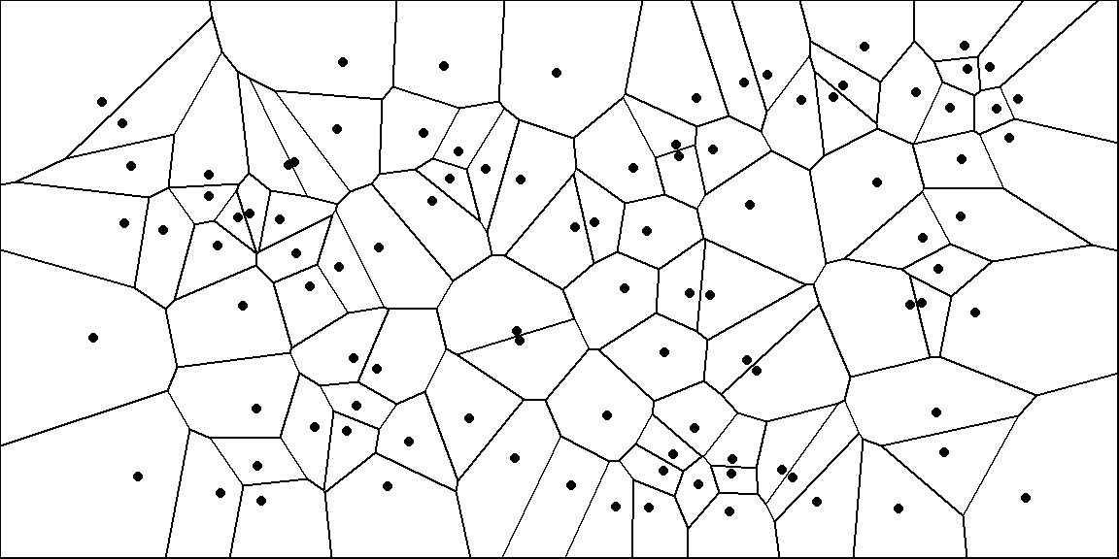

These diagrams match the style of polygons many strategy games (like HOI4) utilize.

Since it may often be difficult to create all the geometry of a specific region, or you know it will take too long to generate all polygons using the method described in **QuickStart**. This method is highly recommended. This software offers tools to tweak Voronoi to work in your interests.

**How does Voronoi work?**

A cluster of points are defined across a 2D space. The algorithm then attempts to create polygons that try to equally divide these points within simple straight lines. In doing so, patterns generated create simple polygons that share edges with no gaps.

## Setting up For Voronoi

There exist two buttons under the Voronoi tab.

* **Generate Voronoi Tiles**: Using the vertices tool offered by the editor (left click) you can define where you want all the Voronoi centroids to be located. Upon clicking the “Generate Voronoi Tiles” button, the centroids disappear and the tile structure is built. *Note:* Once you have created Voronoi Tiles, the vertices that build these tiles will be viewed as new centroids if you click the button again.
* **Generate Random Voronoi Tiles:** This function creates a number of random centroids that you can specify that are distributed across the map randomly. Then it will automatically generate Voronoi tiles around them that create your game tiles.
  + A window will appear asking for an image file. This file acts as a black/white color map that weighs where your Voronoi centroids get placed. (An area in white has a high concentration of centroids than an area in black). *This feature is optional. If you specify no file, it will distribute uniformly.*

## Why Voronoi

Consider this. You want to quickly create your entire map without having to spend too much time hand creating vertices and edges, then waiting endlessly for the polygon generation function to run. Voronoi offers a quick efficient way to create thousands of tiles. You may then move the vertices of these tiles to better positions.

If you don’t like some specific geometry, you can always delete a specific vertex to dissolve its neighboring tiles, then create new vertices and edges to fill its place. This will speed up the process of map creation and map editing significantly.

## Voronoi In Action

As you see many points are not in the correct positions and awfully spread apart, however this generation took less than 5 seconds to create and is fairly easy to edit.

## Special Thanks

I would like to thank Pascal for creating the map I use here for demonstration purposes.

I would also like to thank the **World of Tyrell** community for helping out on this project. 😊